March 12th, 2006
Hi
Again there is not that much to write about. I suppose the main event for me was the visit to the clinic for the biopsy. I took quite a lot of money as I was not sure how much the operation would cost, but it only cost $60 and this was less than the $100 for the previous original appointment. The operation was performed under a local anaesthetic of the same kind a dentist uses. I wanted to watch the procedures but could not see very well, as I was lying down and the areas being operated on were surrounded by cloths. However, for the nose operation, I could see a bit even though it was slightly out of focus. Watched him cutting out a small bit of skin and then sewing it up with nylon thread. After the operation, he covered the wounds with strips of transparent, waterproof but breathable plastic. He also asked if I wanted to get any analgesics (painkillers). Initially I said no but then changed my mind. Wish I had not got them as it took about 45 minutes at the dispensary to get them and they turned out to be just Panadol, rather than some special pain killer I had thought they might be. Anyway, I have not taken any, as there has been no pain. After some hours there was a build up of blood and muck under the plastic strips, so after a day I took them off. It turned out that it was not the operated parts that were causing the oozing, but the initial lesions. By covering them, it had opened them up again to where they were about a year ago do it will now take a long, long time for them to dry up and heal as the one on the foot has. Big nuisance! Consequently, I did not put the covers back on so that the wounds would start to dry out again! I also did not do any exercise for 3 days following the operations, waiting for the wounds to heal a bit first. but then started again, being careful not to get the sutured parts wet. In addition, in weight training, I did not do exercises that would stretch the hand in case that split open the suture; was still able to do 10 of the 14 exercises I normally do. Will also go for a run tomorrow. The weather is expected to be quite cold, which is good, as that will reduce the amount of sweat on the wounds. I go to the clinic again on Thursday to get the sutures removed
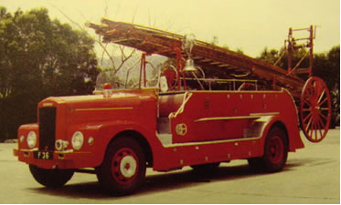
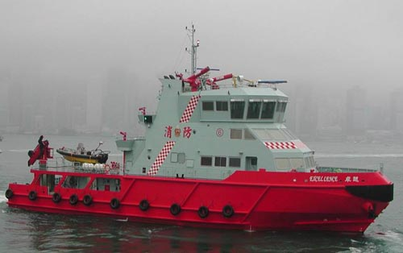
In Hong Kong, an old fireboat, the Alexander Grantham' ‘retired’ and has been restored as a museum. It is about 50 years old and in its time was one of the most advanced fireboats in Asia. You might have seen it in the harbour spouting water on special occasions. (I couldn’t find any pictures of the Alexander Grantham so I have used two others.)
Latest fireboat, built 2004
On the news, heard how confidential complaints against Police files somehow managed to be displayed on the Internet. The files showed the names and details of about 20 000 people who have made complaints in the past few years.
HK fire engine, 1957

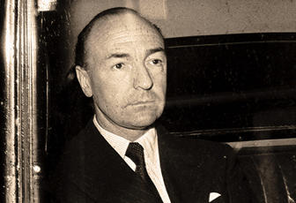
Read about the deaths of two people who had an effect on events in the last century. Saw on the Netscape news just a few minutes ago, that Milosevic, the former president of Serbia, was found dead in his cell in The Hague - apparently from natural causes, as he had heart problems. Then there was John Profumo, who died the other day, aged 91. You will not have heard of him before, though Gavin will probably have heard a lot in the past days. He was a senior cabinet minister in the British government in the early 1960s. He got involved with a call-girl and a Russian spy and caused such a scandal at the time that it eventually brought down the government. He, of course, had to resign from parliament, and then spent the rest of his life working for a London charity where, because of his contacts, was able to raise millions and do a lot for the underprivileged. He probably did more good there than he had ever done in parliament.
John Profumo, 1969
Milosevic
That’s about it for now.

Cheers.

